Basics : JavaEE - JPA & Hibernate

Prepared by

Shankar Karthik & Anita

Object Relational Mapping / Java Persistence API

ORM Tools
The term Object/Relational Mapping refers to the technique of mapping data between object model representations to a relational data model representation. See http://en.wikipedia.org/wiki/Object-relational_mapping for a good high-level discussion.

Advantages:
- Productivity - Reduces development time. Development costs are significantly higher due to a paradigm mismatch between how data is represented in objects versus relational databases.
- ORM Tools takes care of the mapping from Java classes to database tables, and from Java data types to SQL data types. In addition, it provides data query and retrieval facilities. It can significantly reduce development time otherwise spent with manual data handling in SQL and JDBC. You do not need a strong background in SQL to use a ORM Tool
  - ORM tools are designed to relieve the developer from 95% of common data persistence-related programming tasks by eliminating the need for manual, hand-crafted data processing using SQL and JDBC.
- Maintainability – reduces Lines of Code. ORM acts as a buffer when any change in the Application code is not affected in the underlying DBMS. ORM tools insulate the ripple effects on either side.
- Performance – ORM providers are expert in what they do ?
- Vendor Independence - ORM Tools helps to remove or encapsulate vendor-specific SQL code and streamlines the common task of translating result sets from a tabular representation to a graph of objects.
Disadvantages:
- ORM Tools may not be the best solution for data-centric applications that only use stored-procedures to implement the business logic in the database, it is most useful with object-oriented domain models and business logic in the Java-based middle-tier.
- Distributed Readiness.
- Cache is forced on us.
- Less control on SQL Queries.

Popular ORM Tools Available in Market
- Eclipse Link
- Hibernate
- Top Link
http://en.wikipedia.org/wiki/List_of_object-relational_mapping_software

Hibernate Native API Dissected

- The Hibernate configuration file

The resource file hibernate.cfg.xml defines Hibernate configuration information. The connection.driver_class, connection.url, connection.username and connection.password property elements define JDBC connection information.

- The entity Java class

An Entity class uses standard JavaBean naming conventions for property getter and setter methods, as well as private visibility for the fields. Although this is the recommended design, it is not required. The no-argument constructor, which is also a JavaBean convention, is a requirement for all persistent classes. Hibernate needs to create objects for you, using Java Reflection. The constructor can be private. However, package or public visibility is required for runtime proxy generation and efficient data retrieval without bytecode instrumentation.

- The mapping file

The hbm.xml mapping file is used by Hibernate to map metadata and to determine how to load and store objects of the persistent class. The Hibernate mapping file is one choice for providing Hibernate with this metadata.

Hibernate Native API Workflow

- The configuration is loaded - The org.hibernate.cfg.Configuration class is the first thing to notice.

- The org.hibernate.SessionFactory is created. - The org.hibernate.cfg.Configuration then creates the org.hibernate.SessionFactory which is a thread-safe object that is instantiated once to serve the entire application.

- SessionFactory creates Session instances - The org.hibernate.SessionFactory acts as a factory for org.hibernate.Session instances as can be seen in the testBasicUsage method.

- Sessions perform work - A org.hibernate.Session should be thought of as a corollary to a "unit of work".

Configuring Hibernate
You can configure Hibernate using
- A Properties file
- An XML deployment descriptor
- Programmatically.

Connecting to a Database
- Stand-alone built-in connection pool
- javax.sql.DataSource
- Connection pools, including support for two different third-party opensource JDBC connection pools:
  - c3p0
  - proxool
- Application-supplied JDBC connections. This is not a recommended approach and exists for legacy reasons
sessionFactory.openSession( newConnection );

Connection Pooling

Built-in Connection Pooling - this algorithm is rudimentary, and is provided for development and testing purposes. Use a third-party pool for best performance and stability. To use a third-party pool, replace the hibernate.connection.pool_size property with settings specific to your connection pool of choice. This disables Hibernate's internal connection pool.

- c3p0 connection pool- Hibernate uses its org.hibernate.service.jdbc.connections.internal.C3P0ConnectionProvider for connection pooling if you set the hibernate.c3p0.* properties.
Important configuration properties for the c3p0 connection pool

hibernate.c3p0.min_size
hibernate.c3p0.max_size
hibernate.c3p0.timeout
hibernate.c3p0.max_statements

- Proxool connection pool- Hibernate uses its org.hibernate.service.jdbc.connections.internal.ProxoolConnectionProvider for connection pooling if you set the hibernate.proxool.* properties. Unlike c3p0, proxool requires some additional configuration parameters, as described by the Proxool documentation available at http://proxool.sourceforge.net/configure.html.

Important configuration properties for the Proxool connection pool

#Configure Proxool provider using an XML file (.xml is appended automatically)
hibernate.proxool.xml
#Configure the Proxool provider using a properties file (.properties is #appended automatically)
hibernate.proxool.properties
# Whether to configure the Proxool provider from an existing pool
hibernate.proxool.existing_pool
# Proxool pool alias to use. Required.
hibernate.proxool.pool_alias

- Obtaining connections from an application server, using JNDI - To use Hibernate inside an application server, configure Hibernate to obtain connections from an application server javax.sql.Datasource registered in JNDI, by setting at least one of the following properties:

Important Hibernate properties for JNDI datasources

hibernate.connection.datasource (required)
hibernate.jndi.url
hibernate.jndi.class
hibernate.connection.username
hibernate.connection.password

JDBC connections obtained from a JNDI datasource automatically participate in the container-managed transactions of the application server.

- Other connection-specific configuration - You can pass arbitrary connection properties by prepending hibernate.connection to the connection property name. For example, specify a charSet connection property as hibernate.connection.charSet.

You can define your own plugin strategy for obtaining JDBC connections by implementing the interface org.hibernate.service.jdbc.connections.spi.ConnectionProvider and specifying your custom implementation with the hibernate.connection.provider_class property.

Dialects
Although SQL is relatively standardized, each database vendor uses a subset of supported syntax. This is referred to as a dialect. Hibernate handles variations across these dialects through its org.hibernate.dialect.Dialect class and the various subclasses for each vendor dialect.

Customizing Mapping Files
Name | Type of value | Description
length | number | Column length
precision | number | Decimal precision of column
scale | number | Decimal scale of column
<property name="zip" length="5"/>
<property name="balance" precision="12" scale="2"/>
not-null | true or false | Whether a column is allowed to hold null values
unique | true or false | Whether values in the column must be unique
index | string | The name of a multi-column index
unique-key | string | The name of a multi-column unique constraint
<many-to-one name="bar" column="barId" not-null="true"/>
<element column="serialNumber" type="long" not-null="true" unique="true"/>
<many-to-one name="org" column="orgId" unique-key="OrgEmployeeId"/>
<property name="employeeId" unique-key="OrgEmployee"/>
foreign-key | string | The name of the foreign key constraint generated for an association. This applies to <one-to-one>, <many-to-one>, <key>, and <many-to-many> mapping elements.inverse="true" sides are skipped by SchemaExport.
<many-to-one name="bar" column="barId" foreign-key="FKFooBar"/>
sql-type | string | Overrides the default column type. This applies to the <column> element only.
<property name="balance" type="float">
<column name="balance" sql-type="decimal(13,3)"/>
</property>
Default | string | Default value for the column
<property name="credits" type="integer" insert="false">
<column name="credits" default="10"/>
</property>
<version name="version" type="integer" insert="false">
<column name="version" default="0"/>
</property>
Check | string | An SQL check constraint on either a column or a table
<property name="foo" type="integer">
<column name="foo" check="foo > 10"/>
</property>

<class name="Foo" table="foos" check="bar < 100.0">
<property name="bar" type="float"/>
</class>

Set child <column> elements - Many mapping elements accept one or more child <column> elements. This is particularly useful for mapping types involving multiple columns.
<property name="name" type="my.customtypes.Name"/>
<column name="last" not-null="true" index="bar_idx" length="30"/>
<column name="first" not-null="true" index="bar_idx" length="20"/>
<column name="initial"/>
</property>

Hibernate Transaction Usage
- Hibernate uses JDBC connections and JTA resources directly, without adding any additional locking behavior.
- Hibernate does not lock objects in memory. The behavior defined by the isolation level of your database transactions does not change when you use Hibernate.
- The Hibernate org.hibernate.Session acts as a transaction-scoped cache providing repeatable reads for lookup by identifier and queries that result in loading entities.

Transactional Patterns

Session-per-operation anti-pattern
This is an anti-pattern of opening and closing a Session for each database call in a single thread. It is also an anti-pattern in terms of database transactions. Group your database calls into a planned sequence. In the same way, do not auto-commit after every SQL statement in your application. Hibernate disables, or expects the application server to disable, auto-commit mode immediately. Database transactions are never optional. All communication with a database must be encapsulated by a transaction. Avoid auto-commit behavior for reading data, because many small transactions are unlikely to perform better than one clearly-defined unit of work, and are more difficult to maintain and extend.
Note
Using auto-commit does not circumvent database transactions. Instead, when in auto-commit mode, JDBC drivers simply perform each call in an implicit transaction call. It is as if your application called commit after each and every JDBC call.

Session-per-request pattern
This is the most common transaction pattern. The term request here relates to the concept of a system that reacts to a series of requests from a client/user. Web applications are a prime example of this type of system, though certainly not the only one. At the beginning of handling such a request, the application opens a Hibernate Session, starts a transaction, performs all data related work, ends the transaction and closes the Session. The crux of the pattern is the one-to-one relationship between the transaction and the Session.

Within this pattern there is a common technique of defining a current session to simplify the need of passing this Session around to all the application components that may need access to it. Hibernate provides support for this technique through the getCurrentSession method of the SessionFactory. The concept of a "current" session has to have a scope that defines the bounds in which the notion of "current" is valid. This is purpose of the org.hibernate.context.spi.CurrentSessionContext contract. There are 2 reliable defining scopes:

- First is a JTA transaction because it allows a callback hook to know when it is ending which gives Hibernate a chance to close the Session and clean up. This is represented by the org.hibernate.context.internal.JTASessionContext implementation of the org.hibernate.context.spi.CurrentSessionContext contract. Using this implementation, a Session will be opened the first time getCurrentSession is called within that transaction.

- Secondly is this application request cycle itself. This is best represented with the org.hibernate.context.internal.ManagedSessionContext implementation of the org.hibernate.context.spi.CurrentSessionContext contract. Here an external component is responsible for managing the lifecycle and scoping of a "current" session. At the start of such a scope, ManagedSessionContext's bind method is called passing in the Session. At the end, its unbind method is called. Some common examples of such "external components" include:

  - javax.servlet.Filter implementation
  - AOP interceptor with a pointcut on the service methods
  - A proxy/interception container
Important
The getCurrentSession() method has one downside in a JTA environment. If you use it, after_statement connection release mode is also used by default. Due to a limitation of the JTA specification, Hibernate cannot automatically clean up any unclosed ScrollableResults or Iterator instances returned by scroll() or iterate(). Release the underlying database cursor by calling ScrollableResults.close() or Hibernate.close(Iterator) explicitly from a finally block.

Conversations
The session-per-request pattern is not the only valid way of designing units of work. Many business processes require a whole series of interactions with the user that are interleaved with database accesses. In web and enterprise applications, it is not acceptable for a database transaction to span a user interaction. Consider the following example:

An example of a long-running conversation

The first screen of a dialog opens. The data seen by the user is loaded in a particular Session and database transaction. The user is free to modify the objects.
The user uses a UI element to save their work after five minutes of editing. The modifications are made persistent. The user also expects to have exclusive access to the data during the edit session.
Even though we have multiple databases access here, from the point of view of the user, this series of steps represents a single unit of work. There are many ways to implement this in your application.

A first naive implementation might keep the Session and database transaction open while the user is editing, using database-level locks to prevent other users from modifying the same data and to guarantee isolation and atomicity. This is an anti-pattern, because lock contention is a bottleneck which will prevent scalability in the future.

Several database transactions are used to implement the conversation. In this case, maintaining isolation of business processes becomes the partial responsibility of the application tier. A single conversation usually spans several database transactions. These multiple database accesses can only be atomic as a whole if only one of these database transactions (typically the last one) stores the updated data. All others only read data. A common way to receive this data is through a wizard-style dialog spanning several request/response cycles. Hibernate includes some features which make this easy to implement.

- Automatic Versioning - Hibernate can perform automatic optimistic concurrency control for you. It can automatically detect if a concurrent modification occurred during user think time. Check for this at the end of the conversation.
- Detached Objects - If you decide to use the session-per-request pattern, all loaded instances will be in the detached state during user think time. Hibernate allows you to reattach the objects and persist the modifications. The pattern is called session-per-request-with-detached-objects. Automatic versioning is used to isolate concurrent modifications.
- Extended Session - The Hibernate Session can be disconnected from the underlying JDBC connection after the database transaction has been committed and reconnected when a new client request occurs. This pattern is known as session-per-conversation and makes even reattachment unnecessary. Automatic versioning is used to isolate concurrent modifications and the Session will not be allowed to flush automatically, only explicitly.

Common issues
Session-per-request-with-detached-objects and session-per-conversation each have advantages and disadvantages. Both the session-per-user-session and session-per-application anti-patterns are susceptible to the following issues. Some of the issues might also arise within the recommended patterns, so ensure that you understand the implications before making a design decision:

- A Session is not thread-safe. Things that work concurrently, like HTTP requests, session beans, or Swing workers, will cause race conditions if a Session instance is shared. If you keep your Hibernate Session in your javax.servlet.http.HttpSession (this is discussed later in the chapter), you should consider synchronizing access to your HttpSession; otherwise, a user that clicks reload fast enough can use the same Session in two concurrently running threads.
- An exception thrown by Hibernate means you have to rollback your database transaction and close the Session immediately (this is discussed in more detail later in the chapter). If your Session is bound to the application, you have to stop the application. Rolling back the database transaction does not put your business objects back into the state they were at the start of the transaction. This means that the database state and the business objects will be out of sync. Usually this is not a problem, because exceptions are not recoverable and you will have to start over after rollback anyway.
- The Session caches every object that is in a persistent state (watched and checked for changes by Hibernate). If you keep it open for a long time or simply load too much data, it will grow endlessly until you get an OutOfMemoryException. One solution is to call clear() and evict() to manage the Session cache, but you should consider an alternate means of dealing with large amounts of data such as a Stored Procedure. Java is simply not the right tool for these kind of operations. Some solutions are shown in Chapter 4, Batch Processing. Keeping a Session open for the duration of a user session also means a higher probability of stale data.

Object identity
An application can concurrently access the same persistent state (database row) in two different Sessions. However, an instance of a persistent class is never shared between two Session instances. Two different notions of identity exist and come into play here: Database identity and JVM identity.

Database identity → foo.getId().equals( bar.getId() )

JVM identity → foo==bar

For objects attached to a particular Session, the two notions are equivalent, and JVM identity for database identity is guaranteed by Hibernate. The application might concurrently access a business object with the same identity in two different sessions, the two instances are actually different, in terms of JVM identity. Conflicts are resolved using an optimistic approach and automatic versioning at flush/commit time.

This approach places responsibility for concurrency on Hibernate and the database. It also provides the best scalability, since expensive locking is not needed to guarantee identity in single-threaded units of work. The application does not need to synchronize on any business object, as long as it maintains a single thread per anti-patterns. While not recommended, within a Session the application could safely use the == operator to compare objects.

However, an application that uses the == operator outside of a Session may introduce problems. If you put two detached instances into the same Set, they might use the same database identity, which means they represent the same row in the database. They would not be guaranteed to have the same JVM identity if they are in a detached state. Override the equals and hashCode methods in persistent classes, so that they have their own notion of object equality. Never use the database identifier to implement equality. Instead, use a business key that is a combination of unique, typically immutable, attributes. The database identifier changes if a transient object is made persistent. If the transient instance, together with detached instances, is held in a Set, changing the hash-code breaks the contract of the Set. Attributes for business keys can be less stable than database primary keys. You only need to guarantee stability as long as the objects are in the same Set. This is not a Hibernate issue, but relates to Java's implementation of object identity and equality.

Entity States
new  or  transient | the entity has just been instantiated and is not associated with a persistence context. It has no persistent representation in the database and no identifier value has been assigned.
managed  or  persistent | the entity has an associated identifier and is associated with a persistence context.
detached | the entity has an associated identifier, but is no longer associated with a persistence context (usually because the persistence context was closed or the instance was evicted from the context)
removed | the entity has an associated identifier and is associated with a persistence context, however it is scheduled for removal from the database.

Entities Basic Operations (CRUD)

Persisting Entities
Once you've created a new entity instance (using the standard new operator) it is in new state.

Using Native API
DomesticCat fritz = new DomesticCat();
fritz.setColor( Color.GINGER );
fritz.setSex( 'M' );
fritz.setName( "Fritz" );
session.save( fritz );
Using JPA
DomesticCat fritz = new DomesticCat();
fritz.setColor( Color.GINGER );
fritz.setSex( 'M' );
fritz.setName( "Fritz" );
entityManager.persist( fritz );

If the DomesticCat entity type has a generated identifier, the value is associated to the instance when the save or persist is called. If the identifier is not automatically generated, the application-assigned (usually natural) key value has to be set on the instance before save or persist is called.

Deleting entities
Using Native API
session.delete( fritz );
Using JPA
entityManager.remove( fritz );

It is important to note that Hibernate itself can handle deleting detached state. JPA, however, disallows it. The implication here is that the entity instance passed to the org.hibernate.Session delete method can be either in managed or detached state, while the entity instance passed to remove on javax.persistence.EntityManager must be in managed state.

Load Entity without initializing its data
Sometimes referred to as lazy loading, the ability to obtain a reference to an entity without having to load its data is hugely important. The most common case being the need to create an association between an entity and another, existing entity.

Using Native API
Book book = new Book();
book.setAuthor( session.load( Author.class, authorId ) );
Using JPA
Book book = new Book();
book.setAuthor( entityManager.getReference( Author.class, authorId ) );

The above works on the assumption that the entity is defined to allow lazy loading, generally through use of runtime proxies. In both cases an exception will be thrown later if the given entity does not refer to actual database state if and when the application attempts to use the returned proxy in any way that requires access to its data.

Load Entity with data
It is also quite common to want to obtain an entity along with with its data, for display for example.

Using Native API
session.get( Author.class, authorId );
Using JPA
entityManager.find( Author.class, authorId );

In both cases null is returned if no matching database row was found.

Refresh Entity
You can reload an entity instance and it's collections at any time.

Using Native API
Cat cat = session.get( Cat.class, catId );
...
session.refresh( cat );
Using JPA
Cat cat = entityManager.find( Cat.class, catId );
...
entityManager.refresh( cat );

Use Case 1: One case where this is useful is when it is known that the database state has changed since the data was read. Refreshing allows the current database state to be pulled into the entity instance and the persistence context.

Use Case 2: Another case where this might be useful is when database triggers are used to initialize some of the properties of the entity. Note that only the entity instance and its collections are refreshed unless you specify REFRESH as a cascade style of any associations. However, please note that Hibernate has the capability to handle this automatically through its notion of generated properties.

Modifying managed/persistent state
Entities in managed/persistent state may be manipulated by the application and any changes will be automatically detected and persisted when the persistence context is flushed. There is no need to call a particular method to make your modifications persistent.

Using Native API
Cat cat = session.get( Cat.class, catId );
cat.setName( "Garfield" );
session.flush(); // generally this is not explicitly needed
Using JPA
Cat cat = entityManager.find( Cat.class, catId );
cat.setName( "Garfield" );
entityManager.flush(); // generally this is not explicitly needed

Working with detached data

Detachment is the process of working with data outside the scope of any persistence context. Data becomes detached in a number of ways.
- Once the persistence context is closed, all data that was associated with it becomes detached.
- Clearing the persistence context has the same effect.
- Evicting a particular entity from the persistence context makes it detached.
- And finally, serialization will make the deserialized form be detached (the original instance is still managed).

Detached data can still be manipulated, however the persistence context will no longer automatically know about this modification and the application will need to intervene to make the changes persistent.

Reattaching detached data
Reattachment is the process of taking an incoming entity instance that is in detached state and re-associating it with the current persistence context.

Important
JPA does not provide for this model. This is only available through Hibernate org.hibernate.Session.

Using Native API
session.saveOrUpdate( someDetachedCat );

The method name update is a bit misleading here. It does not mean that an SQL UPDATE is immediately performed. It does, however, mean that an SQL UPDATE will be performed when the persistence context is flushed since Hibernate does not know its previous state against which to compare for changes. Unless the entity is mapped with select-before-update, in which case Hibernate will pull the current state from the database and see if an update is needed.

Provided the entity is detached, update and saveOrUpdate operate exactly the same.

Merging detached data
Merging is the process of taking an incoming entity instance that is in detached state and copying its data over onto a new instance that is in managed state.

Object detached = ...;
Object managed = entityManager.find( detached.getClass(), detached.getId() );
managed.setXyz( detached.getXyz() );
...
return managed;

That is not exactly what happens, but it’s a good visualization.

Using Native API
Cat theManagedInstance = session.merge( someDetachedCat );
Using JPA
Cat theManagedInstance = entityManager.merge( someDetachedCat );

Checking persistent state – Verify Managed State

An application can verify the state of entities and collections in relation to the persistence context.

Using Native API
assert session.contains( cat );
Using JPA
assert entityManager.contains( cat );

Checking Persistence State - Verifying laziness
Using Native API
if ( Hibernate.isInitialized( customer.getAddress() ) {
//display address if loaded
}
if ( Hibernate.isInitialized( customer.getOrders()) ) ) {
//display orders if loaded
}
if (Hibernate.isPropertyInitialized( customer, "detailedBio" ) ) {
//display property detailedBio if loaded
}
Using JPA
javax.persistence.PersistenceUnitUtil jpaUtil = entityManager.getEntityManagerFactory().getPersistenceUnitUtil();
if ( jpaUtil.isLoaded( customer.getAddress() ) {
//display address if loaded
}
if ( jpaUtil.isLoaded( customer.getOrders()) ) ) {
//display orders if loaded
}
if (jpaUtil.isLoaded( customer, "detailedBio" ) ) {
//display property detailedBio if loaded
}

In JPA there is an alternative means to check laziness using the following javax.persistence.PersistenceUtil pattern. However, the javax.persistence.PersistenceUnitUtil is recommended where ever possible

Using JPA
javax.persistence.PersistenceUtil jpaUtil = javax.persistence.Persistence.getPersistenceUtil();
if ( jpaUtil.isLoaded( customer.getAddress() ) {
//display address if loaded
}
if ( jpaUtil.isLoaded( customer.getOrders()) ) ) {
//display orders if loaded
}
if (jpaUtil.isLoaded(customer, "detailedBio") ) {
//display property detailedBio if loaded
}

Entities Advanced Operations - Batch Processing

Naive way to insert 100000 lines with Hibernate

Session session = sessionFactory.openSession();
Transaction tx = session.beginTransaction();
for ( int i=0; i<100000; i++ ) {
Customer customer = new Customer(.....);
session.save(customer);
}
tx.commit();
session.close();

This fails with exception OutOfMemoryException after around 50000 rows on most systems. The reason is that Hibernate caches all the newly inserted Customer instances in the session-level cache. There are several ways to avoid this problem.

Before batch processing, enable JDBC batching. To enable JDBC batching, set the property hibernate.jdbc.batch_size to an integer between 10 and 50.

Note
Hibernate disables insert batching at the JDBC level transparently if you use an identity identifier generator.
If the above approach is not appropriate, you can disable the second-level cache, by setting hibernate.cache.use_second_level_cache to false.

Flushing and clearing the Session
Session session = sessionFactory.openSession();
Transaction tx = session.beginTransaction();

for ( int i=0; i<100000; i++ ) {
Customer customer = new Customer(.....);
session.save(customer);
if ( i % 20 == 0 ) { //20, same as the JDBC batch size
//flush a batch of inserts and release memory:
session.flush();
session.clear();
}
}

tx.commit();
session.close();

Using scroll()
Session session = sessionFactory.openSession();
Transaction tx = session.beginTransaction();

ScrollableResults customers = session.getNamedQuery("GetCustomers")
.setCacheMode(CacheMode.IGNORE)
.scroll(ScrollMode.FORWARD_ONLY);
int count=0;
while ( customers.next() ) {
Customer customer = (Customer) customers.get(0);
customer.updateStuff(...);
if ( ++count % 20 == 0 ) {
//flush a batch of updates and release memory:
session.flush();
session.clear();
}
}

tx.commit();
session.close();

JPA Dissected
- JPA Configuration file

The resource file persistence.xml defines JPA configuration information.
Hibernate Native API used the Hibernate-specific hibernate.cfg.xml configuration file. JPA, however, defines a different bootstrap process that uses its own configuration file named persistence.xml. This bootstrapping process is defined by the JPA specification. In Java™ SE environments the persistence provider (Hibernate in this case) is required to locate all JPA configuration files by classpath lookup of the META-INF/persistence.xml resource name.

<persistence xmlns="http://java.sun.com/xml/ns/persistence"
xmlns:xsi="http://www.w3.org/2001/XMLSchema-instance"
xsi:schemaLocation="http://java.sun.com/xml/ns/persistence http://java.sun.com/xml/ns/persistence/persistence_2_0.xsd"
version="2.0">
<persistence-unit name="org.hibernate.tutorial.jpa">
...
</persistence-unit>
</persistence>

persistence.xml files should provide a unique name for each persistence unit. Applications use this name to reference the configuration when obtaining an javax.persistence.EntityManagerFactory reference.
- The entity Java class

An Entity class uses standard JavaBean naming conventions for property getter and setter methods, as well as private visibility for the fields. Although this is the recommended design, it is not required. The no-argument constructor, which is also a JavaBean convention, is a requirement for all persistent classes. Hibernate needs to create objects for you, using Java Reflection. The constructor can be private. However, package or public visibility is required for runtime proxy generation and efficient data retrieval without bytecode instrumentation.

JPA Workflow
- The configuration persistence.xml is loaded.

- Create an EMF once for an application for every persistence unit defined in the persistence.xml.
Persistence.createEntityManagerFactory( "basics" );

- EntityManagerFactory creates EntityManager instances.

- EMs perform work - A EntityManager should be thought of as a corollary to a "unit of work".

JPA Advanced Operations

Pagination in JPA

Query q = entityManager.createQuery("select cat from DomesticCat cat");
q.setFirstResult(20);
q.setMaxResults(10);
List cats = q.getResultList(); //return cats from the 20th position to 29th

Named Queries in JPA
@javax.persistence.NamedQuery(name="eg.DomesticCat.by.name.and.minimum.weight",
query="select cat from eg.DomesticCat as cat where cat.name = ?1 and cat.weight > ?2")

Parameters are bound programmatically to the named query, before it is executed:

Query q = entityManager.createNamedQuery("eg.DomesticCat.by.name.and.minimum.weight");
q.setString(1, name);
q.setInt(2, minWeight);
List<?> cats = q.getResultList();

@SqlResultSetMapping(name="getItem", entities =
@EntityResult(entityClass=org.hibernate.ejb.test.ItentityManager.class, fields= {
@FieldResult(name="name", column="itemname"),
@FieldResult(name="descr", column="itemdescription")
})
)

Native Queries in JPA
Query q = entityManager.createNativeQuery("select name as itemname, descr as itemdescription from Item", "getItem");
item = (Item) q.getSingleResult(); //from a resultset

Query q = entityManager.createNativeQuery("select * from Item", ItentityManager.class);
item = (Item) q.getSingleResult(); //from a class columns names match the mapping

Query lock and flush mode in JPA
You can adjust the flush mode used when executing the query as well as define the lock mode used to load the entities.

Adjusting the flush mode is interesting when one must guaranty that a query execution will not trigger a flush operation. Most of the time you don't need to care about this. Adjusting the lock mode is useful if you need to lock the objects returned by the query to a certain level.

query.setFlushMode(FlushModeType.COMMIT)
query.setLockMode(LockModeType.PESSIMISTIC_READ);

Setting Vendor Properties - Query Hints
Query hints (for performance optimization, usually) are implementation specific. Hints are declared using the query.setHint(String name, Object value) method, or through the @Named(Native)Query(hints) annotation Note that these are not SQL query hints! The Hibernate EJB3 implementation offers the following query hints:

Hibernate query hints
Hint | Description
org.hibernate.timeout | Query timeout in seconds ( eg. new Integer(10) )
org.hibernate.fetchSize | Number of rows fetched by the JDBC driver per roundtrip ( eg. new Integer(50) )
org.hibernate.comment | Add a comment to the SQL query, useful for the DBA ( e.g. new String("fetch all orders in 1 statement") )
org.hibernate.cacheable | Whether or not a query is cacheable ( eg. new Boolean(true) ), defaults to false
org.hibernate.cacheMode | Override the cache mode for this query ( eg. CacheMode.REFRESH )
org.hibernate.cacheRegion | Cache region of this query ( eg. new String("regionName") )
org.hibernate.readOnly | Entities retrieved by this query will be loaded in a read-only mode where Hibernate will never dirty-check them or make changes persistent ( eg. new Boolean(true) ), default to false
org.hibernate.flushMode | Flush mode used for this query (useful to pass Hibernate specific flush modes, in particular MANUAL).

Detaching a persistent object in JPA
An object when loaded in the persistence context is managed by Hibernate. You can force an object to be detached (ie. no longer managed by Hibernate) by closing the EntityManager or in a more fine-grained approach by calling the detach() method.

Cat cat = entityManager.find( Cat.class, new Long(69) );
...
entityManager.detach(cat);
cat.setName("New name"); //not propatated to the database

Modifying detached objects in JPA – EntityManager.merge
Many applications need to retrieve an object in one transaction, send it to the presentation layer for manipulation, and later save the changes in a new transaction. There can be significant user think and waiting time between both transactions. Applications that use this kind of approach in a high-concurrency environment usually use versioned data to ensure isolation for the "long" unit of work.

The JPA specifications supports this development model by providing for persistence of modifications made to detached instances using the EntityManager.merge() method:

// in the first entity manager
Cat cat = firstEntityManager.find(Cat.class, catId);
Cat potentialMate = new Cat();
firstEntityManager.persist(potentialMate);

// in a higher layer of the application
cat.setMate(potentialMate);

// later, in a new entity manager
secondEntityManager.merge(cat); // update cat
secondEntityManager.merge(potentialMate); // update mate

The merge() method merges modifications made to the detached instance into the corresponding managed instance, if any, without consideration of the state of the persistence context. In other words, the merged objects state overrides the persistent entity state in the persistence context, if one is already present. The application should individually merge() detached instances reachable from the given detached instance if and only if it wants their state also to be persistent. This can be cascaded to associated entities and collections, using transitive persistence, see Transitive persistence.

Automatic state detection in JPA– EntityManager.merge
The merge operation is clever enough to automatically detect whether the merging of the detached instance has to result in an insert or update. In other words, you don't have to worry about passing a new instance (and not a detached instance) to merge(), the entity manager will figure this out for you:

// In the first entity manager
Cat cat = firstEntityManager.find(Cat.class, catID);
// In a higher layer of the application, detached
Cat mate = new Cat();
cat.setMate(mate);

// Later, in a new entity manager
secondEntityManager.merge(cat); // update existing state
secondEntityManager.merge(mate); // save the new instance

The usage and semantics of merge() seems to be confusing for new users. Firstly, as long as you are not trying to use object state loaded in one entity manager in another new entity manager, you should not need to use merge() at all. Some whole applications will never use this method.

Usually merge() is used in the following scenario:
- the application loads an object in the first entity manager
- the object is passed up to the presentation layer
- some modifications are made to the object
- the object is passed back down to the business logic layer
- the application persists these modifications by calling merge() in a second entity manager

Here is the exact semantic of merge()
- if there is a managed instance with the same identifier currently associated with the persistence context, copy the state of the given object onto the managed instance
- if there is no managed instance currently associated with the persistence context, try to load it from the database, or create a new managed instance
- the managed instance is returned
- the given instance does not become associated with the persistence context, it remains detached and is usually discarded

Merging vs. saveOrUpdate/saveOrUpdateCopy
Merging in JPA is similar to the saveOrUpdateCopy() method in native Hibernate. However, it is not the same as the saveOrUpdate() method, the given instance is not reattached with the persistence context, but a managed instance is returned by the merge() method.

Deleting managed objects in JPA
EntityManager.remove() will remove an objects state from the database. Of course, your application might still hold a reference to a deleted object. You can think of remove() as making a persistent instance new (aka transient) again. It is not detached, and a merge would result in an insertion.

Flush the persistence context
From time to time the entity manager will execute the SQL DML statements needed to synchronize the data store with the state of objects held in memory. This process is called flushing.

Flush occurs by default (this is Hibernate specific and not defined by the specification) at the following points:
- before query execution
- from javax.persistence.EntityTransaction.commit()
- when EntityManager.flush() is called

It is possible to change the default behavior so that flush occurs less frequently. The FlushModeType for an entity manager defines two different modes: only flush at commit time or flush automatically using the explained routine unless flush() is called explicitly.

em = emf.createEntityManager();
Transaction tx = entityManager.getTransaction().begin();
entityManager.setFlushMode(FlushModeType.COMMIT); // allow queries to return stale state

Cat izi = entityManager.find(Cat.class, id);
izi.setName(iznizi);

// might return stale data
entityManager.createQuery("from Cat as cat left outer join cat.kittens kitten").getResultList();
// change to izi is not flushed!
...
entityManager.getTransaction().commit(); // flush occurs

Transitive persistence in JPA - CascadeType
It is quite cumbersome to save, delete, or reattach individual objects, especially if you deal with a graph of associated objects. A common case is a parent/child relationship. Consider the following example:

If the children in a parent/child relationship would be value typed (e.g. a collection of addresses or strings), their lifecycle would depend on the parent and no further action would be required for convenient "cascading" of state changes. When the parent is persisted, the value-typed child objects are persisted as well, when the parent is removed, the children will be removed, etc. This even works for operations such as the removal of a child from the collection; Hibernate will detect this and, since value-typed objects can't have shared references, remove the child from the database.

Now consider the same scenario with parent and child objects being entities, not value-types (e.g. categories and items, or parent and child cats). Entities have their own lifecycle, support shared references (so removing an entity from the collection does not mean it can be deleted), and there is by default no cascading of state from one entity to any other associated entities. The EJB3 specification does not require persistence by reachability. It supports a more flexible model of transitive persistence, as first seen in Hibernate.

For each basic operation of the entity manager - including persist(), merge(), remove(), refresh() - there is a corresponding cascade style. Respectively, the cascade styles are named PERSIST, MERGE, REMOVE, REFRESH, DETACH. If you want an operation to be cascaded to associated entity (or collection of entities), you must indicate that in the association annotation:

@OneToOne(cascade=CascadeType.PERSIST)

Cascading options can be combined:
@OneToOne(cascade= { CascadeType.PERSIST, CascadeType.REMOVE, CascadeType.REFRESH } )

You may even use CascadeType.ALL to specify that all operations should be cascaded for a particular association. Remember that by default, no operation is cascaded.

JPA LOCKING

With JPA it is possible to lock an entity, this allows you to control when, where and which kind of locking to use.
- JPA 1.0 only supported Optimistic read or Optimistic write locking.
- JPA 2.0 supports Optimistic and Pessimistic locking, this is layered on top of @Version checking.

You can define various levels of locking strategies. A lock can be applied in several ways as listed below:
- via the explicit entityManager.lock() method
- via lookup methods on EntityManager: find(), refresh()
- on queries: query.setLockMode()

You can use various lock JPA 2.0 approaches:
JPA | LOCK MODE | Description
1.0  2.0 | OPTIMISTIC  (previously READ) | - Perform a version check on locked Entity before commit, the version number is compared and has to match before the transaction is committed.  - Throw an OptimisticLockException if Entity version mismatch.
1.0  2.0 | OPTIMISTIC_FORCE_INCREMENT (previously WRITE) | - Perform a version check on locked Entity before commit, the version number is compared and has to match before the transaction is committed.  - Throw an OptimisticLockException if Entity version mismatch  - Force an increment to the version at the end of the transaction, even if the entity is not modified.
2.0 | PESSIMISTIC_READ | - Apply a database-level read lock (LOCK ROW) when the lock operation is requested: roughly concurrent readers are allowed but no writer is allowed.
2.0 | PESSIMISTIC_WRITE | - Apply a database-level write lock when the lock operation is requested: roughly no reader nor writer is allowed.  - Force an increment to the version at the end of the transaction, even if the entity is not modified.

All these locks prevent dirty reads and non-repeatable reads on a given entity. Optimistic locks enforce the lock as late as possible hoping nobody changes the data underneath while pessimistic locks enforce the lock right away and keep it till the transaction is committed.

https://blogs.oracle.com/carolmcdonald/entry/jpa_2_0_concurrency_and

Optimistic locking
Optimistic locking lets concurrent transactions process simultaneously, but detects and prevent collisions, this works best for applications where most concurrent transactions do not conflict. JPA Optimistic locking allows anyone to read and update an entity, however a version check is made upon commit and an exception is thrown if the version was updated in the database since the entity was read. In JPA for Optimistic locking you annotate an attribute with @Version as shown below:
public class Employee {
@ID int id;
@Version int version;
The Version attribute will be incremented with a successful commit. The Version attribute can be an int, short, long, or timestamp. This results in SQL like the following:
“UPDATE Employee SET ..., version = version + 1
WHERE id = ? AND version = readVersion”

Advantages:
The advantages of optimistic locking are that no database locks are held which can give better scalability.
Disadvantages:
The disadvantages are that the user or application must refresh and retry failed updates.

Optimistic Locking Example
In the optimistic locking example below, 2 concurrent transactions are updating employee e1. The transaction on the left commits first causing the e1 version attribute to be incremented with the update. The transaction on the right throws an OptimisticLockException because the e1 version attribute is higher than when e1 was read, causing the transaction to roll back.
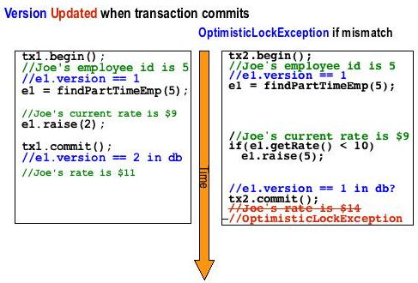

OPTIMISTIC (READ) LockMode
In the optimistic locking example below, Transaction1 tx1 on the left updates the department name for dep , which causes dep's version attribute to be incremented. Transaction2 tx2 on the right gives an employee a raise if he's in the "Eng" department. Version checking on the employee attribute would not throw an exception in this example since it was the dep Version attribute that was updated in transaction1. In this example the employee change should not commit if the department was changed after reading, so an OPTIMISTIC lock is used: em.lock(dep, OPTIMISTIC). This will cause a version check on the dep Entity before committing transaction2 which will throw an OptimisticLockException because the dep version attribute is higher than when dep was read, causing the transaction to roll back.
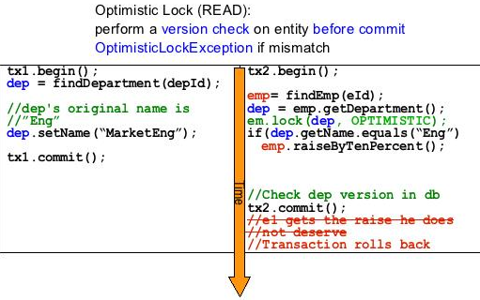

OPTIMISTIC_FORCE_INCREMENT (write) LockMode
In the OPTIMISTIC_FORCE_INCREMENT locking example below, Transaction2 tx2on the right wants to be sure that the dep name does not change during the transaction, so Transaction2 tx2 locks the dep Entity em.lock(dep, OPTIMISTIC_FORCE_INCREMENT) and then calls entityManager.flush() which causes dep 's version attribute to be incremented in the database. This will cause any parallel updates to dep to throw an OptimisticLockException and roll back. In Ttransaction1 tx1 on the left at commit time when the dep version attribute is checked and found to be stale, an OptimisticLockException is thrown
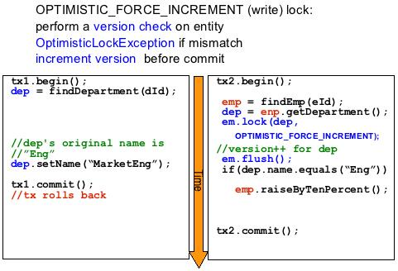
Pessimistic Concurrency
Pessimistic concurrency locks the database row when data is read, this is the equivalent of a (SELECT . . . FOR UPDATE [NOWAIT])
Pessimistic locking ensures that transactions do not update the same entity at the same time, which can simplify application code, but it limits concurrent access to the data which can cause bad scalability and may cause deadlocks. Pessimistic locking is better for applications with a higher risk of contention among concurrent transactions.
The examples below show:
- reading an entity and then locking it later
- reading an entity with a lock
- reading an entity, then later refreshing it with a lock
The Trade-offs are the longer you hold the lock the greater the risks of bad scalability and deadlocks. The later you lock the greater the risk of stale data, which can then cause an optimistic lock exception, if the entity was updated after reading but before locking.

Caching & Persistence Context
http://blogs.sun.com/carolmcdonald/entry/jpa_caching

JPA L1 Caching
JPA has 2 levels of caching. The first level of caching is the Persistence Context.
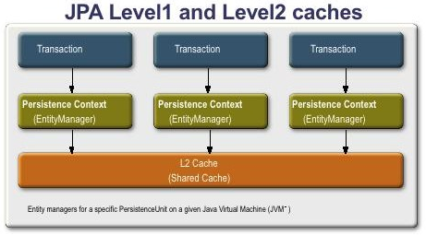
The JPA Entity Manager maintains a set of Managed Entities in the Persistence Context.
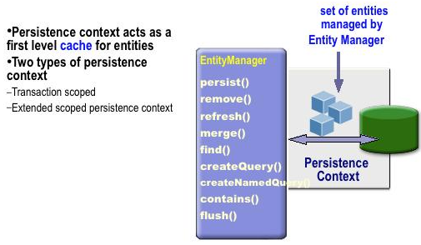
The Entity Manager guarantees that within a single Persistence Context, for any particular database row, there will be only one object instance. However the same entity could be managed in another User's transaction, so you should use either optimistic or pessimistic locking as explained above

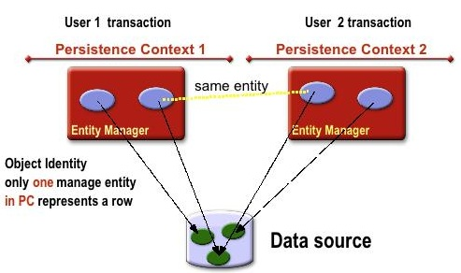
The code below shows that a find on a managed entity with the same id and class as another in the same persistence context , will return the same instance.

@Stateless public ShoppingCartBean implements ShoppingCart {
@PersistenceContext EntityManager entityManager;
public OrderLine createOrderLine(Product product,Order order) {
OrderLine orderLine = new OrderLine(order, product);
entityManager.persist(orderLine); //Managed
OrderLine orderLine2 =entityManager.find(OrderLine,
orderLine.getId()));
(orderLine == orderLine2) // TRUE
return (orderLine);
}
}

The diagram below shows the life cycle of an Entity in relation to the Persistent Context.
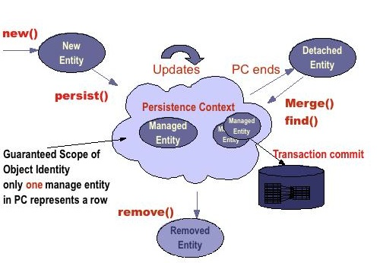
The code below illustrates the life cycle of an Entity. A reference to a container managed EntityManager is injected using the persistence context annotation. A new order entity is created and the entity has the state of new. Persist is called, making this a managed entity. Because it is a stateless session bean it is by default using container managed transactions , when this transaction commits , the order is made persistent in the database. When the orderline entity is returned at the end of the transaction it is a detached entity.
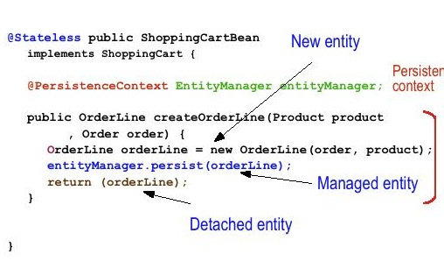
The Persistence Context can be either Transaction Scoped -- the Persistence Context 'lives' for the length of the transaction, or Extended -- the Persistence Context spans multiple transactions. With a Transaction scoped Persistence Context, Entities are "Detached" at the end of a transaction.
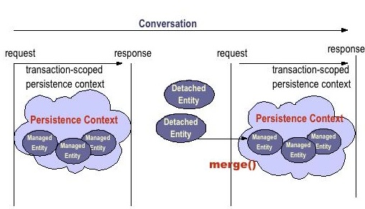
As shown below, to persist the changes on a detached entity, you call the EntityManager's merge() operation, which returns an updated managed entity, the entity updates will be persisted to the database at the end of the transaction.
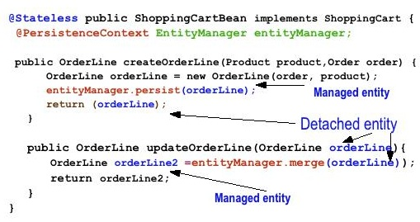
An Extended Persistence Context spans multiple transactions, and the set of Entities in the Persistence Context stay Managed. This can be useful in a work flow scenario where a "conversation" with a user spans multiple requests.
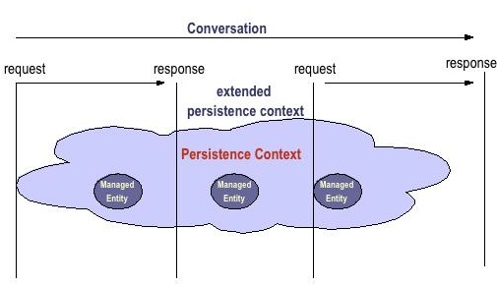
The code below shows an example of a Stateful Session EJB with an Extended Persistence Context in a use case scenario to add line Items to an Order. After the Order is persisted in the createOrder method, it remains managed until the EJB remove method is called. In the addLineItem method , the Order Entity can be updated because it is managed, and the updates will be persisted at the end of the transaction.
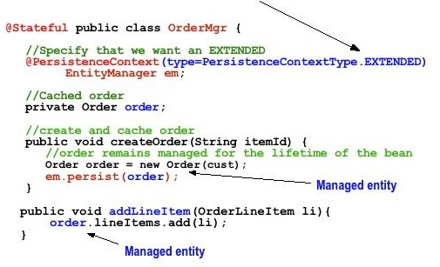
The example below contrasts updating the Order using a transaction scoped Persistence Context verses an extended Persistence context. With the transaction scoped persistence context, an Entity Manager find must be done to look up the Order, this returns a Managed Entity which can be updated. With the Extended Persistence Context the find is not necessary. The performance advantage of not doing a database read to look up the Entity, must be weighed against the disadvantages of memory consumption for caching, and the risk of cached entities being updated by another transaction. Depending on the application and the risk of contention among concurrent transactions this may or may not give better performance / scalability.
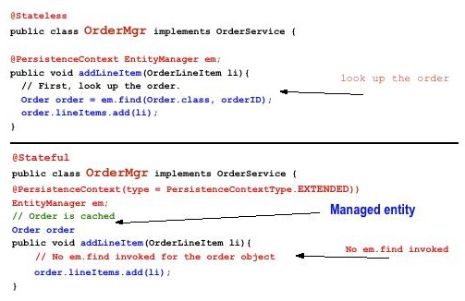

JPA L2 Caching - Second Level Caching
JPA second level (L2) caching shares entity state across various persistence contexts.
JPA 1.0 did not specify support of a second level cache; however, most of the persistence providers provided support for second level cache(s). JPA 2.0 specifies support for basic cache operations with the new Cache API, which is accessible from the EntityManagerFactory, shown below:
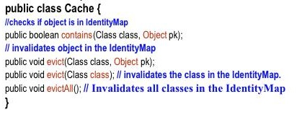

If L2 caching is enabled, entities not found in persistence context, will be loaded from L2 cache, if found.
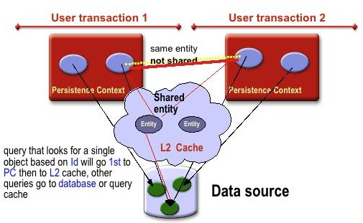
L2 Caching Advantages:
- avoids database access for already loaded entities
- faster for reading frequently accessed unmodified entities

L2 Caching Disadvantages:
- memory consumption for large amount of objects
- Stale data for updated objects
- Concurrency for write (optimistic lock exception, or pessimistic lock)
- Bad scalability for frequent or concurrently updated entities
You should configure L2 caching for entities that are:
- read often
- modified infrequently
- Not critical if stale
You should protect any data that can be concurrently modified with a locking strategy:
- Must handle optimistic lock failures on flush/commit
- configure expiration, refresh policy to minimize lock failures

Query Cache
The Query cache is useful for queries that are run frequently with the same parameters, for not modified tables.

The EclipseLink JPA persistence provider caching Architecture is shown below.
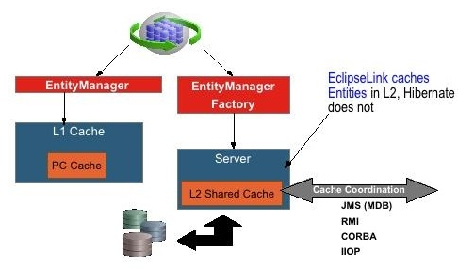
Support for second level cache in EclipseLink is turned on by default, entities read are L2 cached. You can disable the L2 cache. EclipseLink caches entities in L2, Hibernate caches entity id and state in L2. You can configure caching by Entity type or Persistence Unit with the following configuration parameters:
Cache isolation, type, size, expiration, coordination, invalidation, refreshing
Coordination (cluster-messaging)
Messaging: JMS, RMI, RMI-IIOP, …
Mode: SYNC, SYNC+NEW, INVALIDATE, NONE
The example below shows configuring the L2 cache for an entity using the @Cache annotation
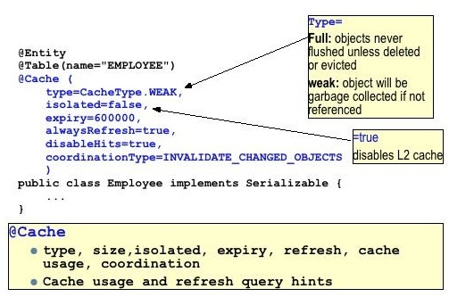

The Hibernate JPA persistence provider caching Architecture
The Hibernate JPA persistence provider caching architecture is different than EclipseLink: it is not configured by default; it does not cache entities just id and state, and you can plug in different L2 caches. The diagram below shows the different L2 cache types that you can plug into Hibernate.
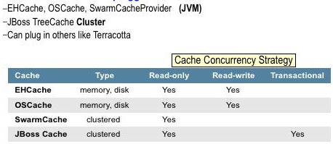
The configuration of the cache depends on the type of caching plugged in. The example below shows configuring the hibernate L2 cache for an entity using the @Cache annotation
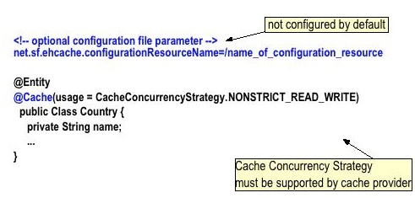

http://www.javadev.org/files/Hibernate%20Performance%20Tuning.pdf
http://docs.jboss.org/hibernate/stable/entitymanager/reference/en/html/transactions.html#d0e2782

When the second-level cache is activated Hibernate ensures it is used and properly updated. You can however adjust these settings by passing two properties:
- javax.persistence.cache.retrieveMode which accepts CacheRetrieveMode values
- javax.persistence.cache.storeMode which accepts CacheStoreMode values

CacheRetrieveMode controls how Hibernate accesses information from the second-level cache:
- USE which is the default or
- BYPASS which means ignore the cache.
CacheStoreMode controls how Hibernate pushes information to the second-level cache:
- USE which is the default and push data in the cache when reading from and writing to the database,
- BYPASS which does not insert new data in the cache (but can invalidate obsolete data) and
- REFRESH which does like default but also force data to be pushed to the cache on database read even if the data is already cached.

You can set these properties:
- on a particular EntityManager via the setProperty method
- on a query via a query hint (setHint method)
- when calling find() and refresh() and passing the properties in the appropriate Map

JPA also introduces an API to interrogate the second-level cache and evict data manually.

Cache cache = entityManagerFactory.getCache();
if ( cache.contains(User.class, userId) ) {
//load it as we don't hit the DB
}

cache.evict(User.class, userId); //manually evict user form the second-level cache
cache.evict(User.class); //evict all users from the second-level cache
cache.evictAll(); //purge the second-level cache entirely
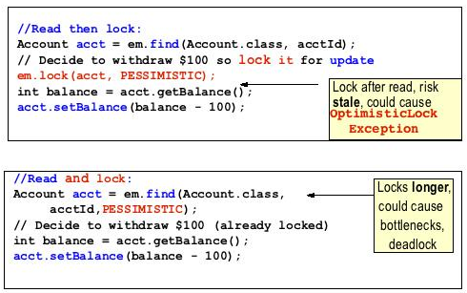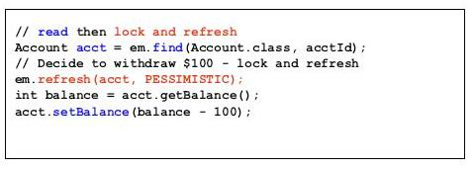

Hibernate Performance Tuning
http://www.javadev.org/files/Hibernate%20Performance%20Tuning.pdf

Mapping Associations

Mapping Inheritence

ORM Development Process

Top down
In top-down development, you start with an existing Java domain model (ideally implemented with POJOs/JavaBeans) and complete freedom with respect to the database schema. You must create a mapping document—either manually using a text editor (recommended is an IDE with XML auto-completion) or automatically using XDoclet—and then let Hibernate’s hbm2ddl tool generate the database schema. In the absence of an existing data model, this is the most comfortable development
style for most Java developers. You can even use the Hibernate tools to automatically refresh the database schema on every application restart in development.

Bottom up
Conversely, bottom-up development begins with an existing database schema and data model. In this case, the easiest way to proceed is to use Middlegen to generate Hibernate mapping documents and then run the hbm2java tool and generate skeletal POJO persistent classes. You’ll usually have to enhance and modify the generated Hibernate mapping by hand, because not all class association details and Javaspecific meta-information can be automatically generated from an SQL schema.

Middle out (metadata oriented)
Neither Java classes (without XDoclet annotations) nor DDL schemas contain enough information to be able to completely deduce an ORM. Hence, if you wish to generate the Hibernate mapping document instead of writing it by hand, you’ll need extra input from the user. In the case of XDoclet, this information is provided by XDoclet attributes embedded in the source code. In the case of Middlegen, it’s provided via the Middlegen GUI. On the other hand, the mapping document does provide sufficient information to completely deduce the DDL schema and to generate working JavaBeans. Furthermore,
the mapping document isn’t too verbose. So, you may prefer middle-out development, where you begin with a handwritten Hibernate mapping document and generate the DDL using hbm2ddl and Java classes using hbm2java.

Meet in the middle
The most difficult scenario combines existing Java classes and an existing relational schema. In this case, there is little that the Hibernate toolset can do to help. It isn’t possible to map arbitrary Java domain models to a given schema, so this scenario usually requires at least some refactoring of the Java classes, database schema, or both. The mapping document must almost certainly be written by hand (although it might be possible to use XDoclet). This is an incredibly painful scenario that is, fortunately, exceedingly rare.

Roundtripping
The notion of roundtripping is that any one of the three kinds of artifacts (Java classes, mapping documents, database schema) should be sufficient to reproduce the other two. Each tool should be completely reversible. You’ve already seen that this isn’t the case. At the very least, you must add XDoclet annotations to the Java classes. Worse, it’s never possible to fully reproduce the Java domain model or ORM from only the database schema. Nevertheless, the Hibernate team is attempting to achieve a slightly less ambitious goal for the Hibernate toolset. Suppose you start with an existing database schema. Then the following steps should reproduce this schema exactly, with minimal
user intervention:
- Use Middlegen to create a mapping document
- Use hbm2java to generate annotated Java classes
- Use XDoclet to regenerate the mapping document
- Use hbm2ddl to generate the DDL
At the time of this writing, there is still work to be done before this approach works perfectly, because it involves many different tools and metamodel conversions.

N+1 Selects Problem
n Select for n items + 1 Select for a Collection Wrapper

Misscellaneous

Transitive Persistence?
Transitive persistence is a technique that allows you to propagate persistence to transient and detached subgraphs automatically.

Hibernate’s transitive persistence model uses the same basic concept as persistence by reach ability—that is, object associations are examined to determine transitive state. However, Hibernate allows you to specify a cascade style for each association mapping, which offers more flexibility and fine-grained control for all state transitions. Hibernate reads the declared style and cascades operations to associated objects automatically. By default, Hibernate does not navigate an association when searching for transient or detached objects, so saving, deleting, or reattaching a Category won’t affect the child category objects. This is the opposite of the persistence-by-reachability default behavior. If, for a particular association, you wish to enable transitive persistence, you must override this default in the mapping metadata.

This association-level cascade style model is both richer and less safe than persistence by reachability. Hibernate doesn’t make the same strong guarantees of referential integrity that persistence by reachability provides. Instead, Hibernate partially delegates referential integrity concerns to the foreign key constraints of the underlying relational database. Of course, there is a good reason for this design decision: It allows Hibernate applications to use detached objects efficiently, because you can control reattachment of a detached object graph at the association level.

Persistence by Reachability?
Persistence by reachability guarantees referential integrity; any object graph can be completely re-created by loading the persistent root object. An application may walk the object graph from association to association without worrying about the persistent state of the instances. (SQL databases have a different approach to referential integrity, relying on foreign key and other constraints to detect a misbehaving application)

Difference between “evict()” and “flush()”
A call to evict() removes the object and its collections from the first level cache.
A call to flush() synchronizes the state of the object with the underlying database.
evict() can be used when mass operations such as bulk update is done. A call to evict after every update operation saves memory.

Inheritance Mapping in EJB3
InheritanceType.SINGLE_TABLE
InheritanceType.JOINED
InheritanceType.TABLE_PER_CLASS

Strategy | Hibernate Equivalent
Table [Single]  Per  Class  Hierarchy | <subclass> | @Entity  @Inheritance(strategy=InheritanceType.SINGLE_TABLE)  @DiscriminatorColumn(  name="PLANE_TYPE",  discriminatorType=DiscriminatorType.STRING  )  @DiscriminatorValue("Plane")  public class Plane { ... }  @Entity  @DiscriminatorValue("A320")  public class A320 extends Plane { ... }
Joined Subclass  [Table for Root + Table for Every Child – only for child properties] | <joined-subclass> | @Entity  @Inheritance(strategy=InheritanceType.JOINED)  public class Boat implements Serializable { ... }  @Entity  public class Ferry extends Boat { ... }  @Entity  @PrimaryKeyJoinColumn(name="BOAT_ID")  public class AmericaCupClass extends Boat { ... }
Table  per Concrete class | <union-class> | @Entity  @Inheritance(strategy = InheritanceType.TABLE_PER_CLASS)  public class Flight implements Serializable {
Inherit Properties from a Superclass |  | @MappedSuperclass  public class BaseEntity {  @Basic  @Temporal(TemporalType.TIMESTAMP)  public Date getLastUpdate() { ... }  public String getLastUpdater() { ... }  ...  }  @Entity class Order extends BaseEntity {  @Id public Integer getId() { ... }  ...  }
SINGLE:
Advantages:
- Simple to implement as it involves one table.
- No complex multi-selects or UNIONS involved.
Disadvantages:
- Huge disadvantage of this approach is all subclass properties should be nullable. If you need or want to have any NOT NULL constraints defined on these columns , you cannot do so.
- Also subclass properties may not be used, the table is not normalized.
FLIGHT_ID | DISCRIMINATOR_COLUMN | FLIGHT_ATTR1 | FLIGHT_ATTR2 | FLIGHT_ATTR3
A_1 | AIRBUS | null | abcd | Null
B_1 | BOEING | 123 | null | null
A_2 | AIRBUS | Null | Def | Null

JOINED:
Advantages:
- Similar to TABLE_PER_CLASS except that Table is normalized.
Disadvantages:
- Containers (ORM Tools) implement this by forming multiple select queries or using SQL UNIONS. While using multiple queries one has to make multiple round trips – a performance hit. With SQL UNIONS – not all DB support UNIONS, but still UNIONS are better than multi-select strategy.
FLIGHT_ID | FLIGHT_NAME | NUM_OF_PILOTS | ENGINE
1 | BOEING_1 | 2 | 2
2 | BOEING_2 | 2 | 2
3 | AIRBUS_1 | 2 | 2

FLIGHT_ID | BOEING_ATTR1 | BOEING_ATTR2 | BOEING_ATTR3
1 | 123 | 456 | 789

FLIGHT_ID | AIRBUS_ATTR1 | AIRBUS_ATTR2
3 | abc | def

TABLE_PER_CLASS
Advantages:
- Easy to define constraints on subclasses
Disadvantages:
- Redundant columns in all tables and not normalized.
- Containers (ORM Tools) implement this by forming multiple select queries or using SQL UNIONS. While using multiple queries one has to make multiple round trips – a performance hit. With SQL UNIONS – not all DB support UNIONS, but still UNIONS are better than multi-select strategy.
FLIGHT_ID | FLIGHT_NAME | NUM_OF_PILOTS | ENGINE
1 | BOEING_1 | 2 | 2
2 | BOEING_2 | 2 | 2
3 | BOEING_3 | 2 | 2

FLIGHT_ID | FLIGHT_NAME | NUM_OF_PILOTS | ENGINE
1 | AIRBUS_1 | 2 | 2

Relationships in EJB3
Asssociation | UniDirectional | Bi-Directional
One  To  One | @JoinColumn( name="passport_fk" ) | To declare a side as not responsible for the relationship, the attribute mappedBy=”ownercolumn” is used.
Many
To
One
One  To  Many |  | Since many to one are (almost) always the owner side of a bidirectional relationship in the EJB3 spec, the one to many association is annotated by @OneToMany( mappedBy=... )  To map a bidirectional one to many, with the one-to-many side as the owning side, you have to remove the mappedBy element and set the many to one @JoinColumn as insertable and updatable to false. This solution is obviously not optimized and will produce some additional UPDATE statements.
Many
To
One

Unidirectional Associations
ManyToOne
::Relationship::
person(many) -> address(one)
::DB Schema::
person( personId, addressId )
address( addressId )
::Java Operation::
person.getAddress();
::Annotation::
@Entity
@Table(name="PERSON")
public class Person {

@Id
@GeneratedValue(strategy = GenerationType.AUTO)
private int id;

@ManyToOne
@JoinColumn(name = "ADDRESS_ID")
private Address address;

public Address getAddress() {
return address;
}
}

@Entity
@Table(name="ADDRESS")
public class Address {

@Id
@GeneratedValue(strategy = GenerationType.AUTO)
private int id;
}

OneToOne (with Foreign Key)
::Relationship::
person(one) -> address(one)
::DB Schema::
person( personId, addressId )
address( addressId )
::Java Operation::
person.getAddress();
::Annotation::
@Entity
@Table(name="PERSON")
public class Person {

@Id
@GeneratedValue(strategy = GenerationType.AUTO)
@Column(name=”personId”)
private int id;

@OneToOne
@JoinColumn(name = "ADDRESS_ID")
private Address address;

@Entity
@Table(name="ADDRESS")
public class Address {

@Id
@GeneratedValue(strategy = GenerationType.AUTO)
@Column(name=”addressId”)
private int id;
}

OneToOne (with Primary Key)
::Relationship::
person(one) -> address(one)
::DB Schema::
person( personId )
address( personId )
** Address’s primary Key is same as person’s primary key.
::Java Operation::
person.getAddress();
::Annotation::
@Entity
@Table(name="PERSON")
public class Person {

@Id
@GeneratedValue(strategy = GenerationType.AUTO)
@Column(name=”peronId”)
private int id;

@ToOneToOne
@PrimaryKeyJoinColumn
private Address address;

public Address getAddress() {
return address;
}
}

@Entity
@Table(name="ADDRESS")
public class Address {

@Id
@Column(name = “personId”)
private int id;
}
::Generated SQL (mysql5.0)::
- person.getAddress();
select person0_.personId as personId2_2_, address1_.personId as personId3_0_, person2_.personId as personId2_1_ from PERSON person0_ left outer join ADDRESS address1_ on person0_.personId=address1_.personId left outer join PERSON person2_ on address1_.personId=person2_.personId where person0_.personId=?

OneToMany (with Foreign Key)
::Relationship::
person(one) -> address(many)
::DB Schema::
person( personId )
address( addressId, personId )
::Java Operation::
person.getAddresses();
::Annotation::
@Entity
@Table(name="PERSON")
public class Person {

@Id
@GeneratedValue(strategy = GenerationType.AUTO)
@Column(name=”personId”)
private int id;

@OneToMany
@JoinColumn(name = "peronId")
private Set<Address> address;

public Address getAddress() {
return address;
}
}

@Entity
@Table(name="ADDRESS")
public class Address {

@Id
@GeneratedValue(strategy = GenerationType.AUTO)
@Column(name=”addressId”)
private int id;
}

Unidirectional Associations with Join Table
OneToMany
ManyToOne
OneToOne
ManyToMany

Bidirectional Associations
OneToMany/ManyToOne
OneToOne (with Foreign Key)
OneToOne (with Primary Key)

Bidirectional Associations with Join Table
OneToMany/ManyToOne
OneToOne
OneToOne

